**GIT**

What is GIT? It is a version control system. Instead of having 100 files named schedule and saving them to see all the adjustments we’ve made over the past ten years, we can save one file and it’s history is saved for us on Github, so we can go back and see any of the previous editions of that file.

Why use GIT? In addition to the benefit above, we have ready access to GIT and don’t have instant access to our website (we have to go through Wilson Wong every time to get things posted and he’s slow).

Note: if you are using a windows machine then the equivalent of Terminal is Command Prompt.

**Setting up GIT**

* First, download GIT from here and follow the directions that come with it: <https://git-scm.com/downloads>
* Next, use Spotlight in the top right corner to open up a Terminal. 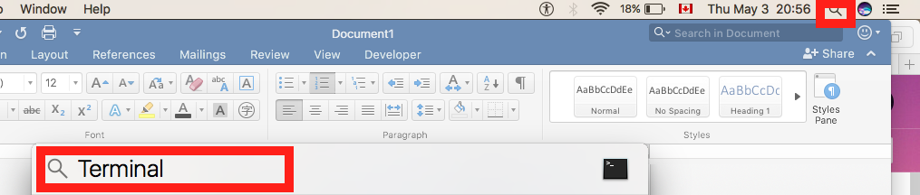
* Let’s go over some basic commands for navigating:
  + ls (for Mac) dir (for Windows) -> this command will list all the subfolders in the current folder.
  + cd -> stands for change directory. It’s how you navigate. If you want to go into a folder type cd “Folder Name”. Include quotes so you can use spaces. If you want to back out of a folder type cd ../
  + mkdir (for Mac) md (for Windows) -> this will make a new folder inside your current folder. Ex. mkdir “Track Meet”
* Use the cd command to move to a place where you would like to setup your track folder. When you arrive there, use mkdir to make the folder, then cd once more to go inside it.
* Type mkdir GIT press Enter
* Type cd GIT press Enter
* Type mkdir Elementary press Enter
* Type mkdir “UBC Open” press Enter
* Type mkdir Admin press Enter
* In order to use Git you will need to setup a SSH Key. To Create an SSH Key. To do so follow the instructions here under Generating a New SSH Key: <https://help.github.com/articles/generating-a-new-ssh-key-and-adding-it-to-the-ssh-agent/>
* In your command line type cat ~/.ssh/github_rsa.pub if that doesn’t work try cat ~/.ssh/id_rsa.pub, then copy the whole value from the ssh-rsa down to the last character before the very last line. 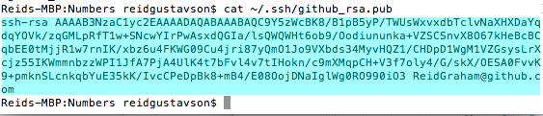
* Now open a web browser and login to github.com with the same login credentials as [ubcmeetdirector@gmail.com](mailto:ubcmeetdirector@gmail.com) account. Then click on the weird symbol in the top right, choose settings, and on the left choose SSH and GPG Keys.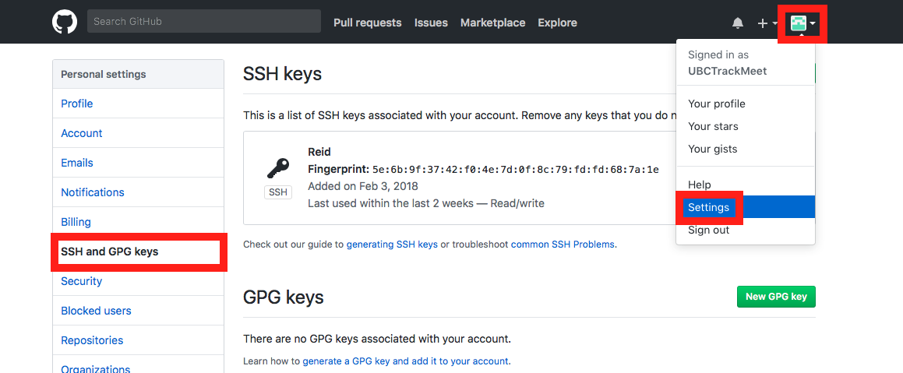
* Choose “New SSH Key” and paste the key you just created here and press “Add SSH Key”
* Keep this browser open and click on the cat icon in the top left. All of the folders you will need, or “repositories” will be on this page. Click on ElementarySchedule to start.   
   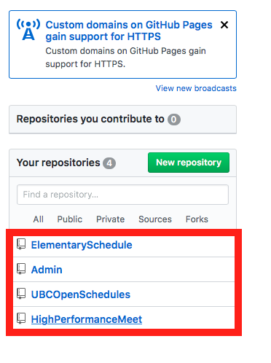
* Click on “Clone or download” then copy that address.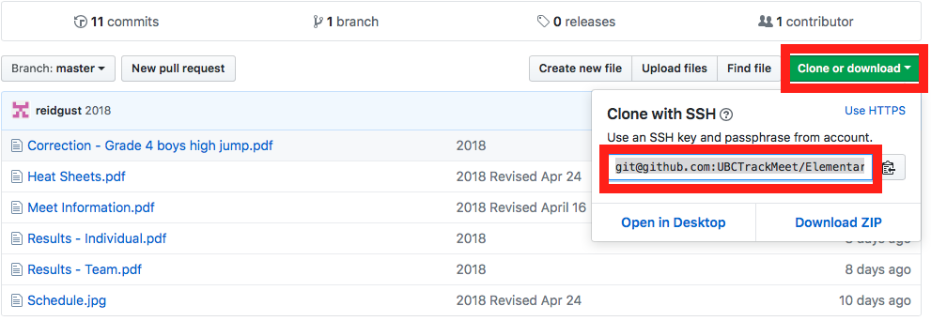
* Back in the command line type cd Elementary press enter
* Now type git init this will initialize the directory.
* Now type git clone TheAddressYouJustCopiedFromGitHub
* Type cd ../
* Repeat this process for the UBC Open and the Admin folders.
* You are now setup.

**Making Changes on GIT**

* The hard part is done. Now if you want to make changes to files, just make sure they end up in the git folder and have the exact same name as the file you want to over-write. You can use regular finder windows for this.
* When you want to upload it to git, open up a terminal window, navigate to the folder using cd commands.
* Once you’re in the right folder type git add “filename.type” press enter.
* Type git commit –m “The Message For your Commit Like a revision Date” press enter.
* Type git push press enter.
* That’s it, changes are up.